SYSTEM DESIGN SPECIFICATION
Project Name: Bright Skills Development Center Management System
Version: 1.0
Status: Design and Development Phase

1. Executive Summary
The Bright Skills Development Center Management System is a robust, web-based platform designed to streamline the student enrollment lifecycle. It digitizes the traditional admission process, moving from manual paperwork to a centralized digital workflow. The system handles user registration, multi-step student applications, course management, payment verification, and real-time communication between students and administration.

2. System Architecture
The system follows the Model-View-Template (MVT) architectural pattern provided by the Django framework, integrated with Asynchronous Server Gateway Interface (ASGI) to support real-time features.
- Frontend (Client-Side): Responsive web interface built with HTML5, CSS3, and Bootstrap 5. It ensures accessibility across desktops, tablets, and mobile devices.
- Backend (Server-Side): Python-based logic using Django. It handles data processing, business rules, and security.
- Real-Time Layer: Django Channels with Daphne serves WebSocket connections for live chat and instant notifications.
- Database: Relational database management system (SQLite for development, PostgreSQL recommended for production) to store structured data.

3. Technology Stack
Component | Technology | Description
Backend Framework | Django 5.x (Python) | Core logic, ORM, and security features.
Async Protocol | Django Channels | Handles WebSockets for real-time chat.
Server | Daphne / Gunicorn | ASGI/WSGI application servers.
Frontend | Bootstrap 5, JavaScript | Responsive UI and dynamic client-side interactions.
Database | SQLite / PostgreSQL | Data persistence.
Admin Interface | Jazzmin | Enhanced, user-friendly administrative dashboard.

4. Database Design (Schema Overview)
The database is normalized to ensure data integrity. Key entities include:

4.1. User Management
- User: Stores authentication credentials (username, password, email).
- Profile: Extends the User model to track system-specific attributes like payment status (Unpaid, Pending, Approved).

4.2. Academic Data
- Course: Contains course details (Title, Description, Cost, Duration, Lecturer, Image).
- Session: Defines available time slots or intakes for courses.
- Student: Stores applicant personal details (Full Name, DOB, Phone, Address).
- Enrollment: Links a student to a course and a specific session.

4.3. Location Data
- Region: Geographic regions for student demographics.
- District: Sub-units of regions.

4.4. Communication
- Chat/Message: Stores real-time conversation history.
- CourseComment: Stores student reviews and ratings for courses.

5. Functional Modules

5.1. Student Application Portal
A guided, multi-step wizard ensures complete data collection:
- Registration: User creates an account.
- Personal Information: User fills in bio-data and location (Region/District).
- Payment Processing:
  - System displays payment instructions.
  - User marks payment as "Complete".
  - System notifies Admin via Email.
  - User waits for Admin approval (Status: Pending).
- Course Selection: Once payment is approved, the user selects their desired courses and sessions.

5.2. Administrative Dashboard
A powerful backend interface for staff to:
- Manage Applications: View and edit student details.
- Approve Payments: Review "Pending" payments and approve them to unlock course selection for students.
- Course Management: Add, edit, or remove courses and sessions.
- Analytics: View dashboard statistics (Total Students, Revenue, Popular Courses).

5.3. Communication Hub
- Live Chat: Real-time messaging between students and support staff.
- Course Reviews: Students can rate courses and leave comments, providing social proof for prospective applicants.

6. User Flow Diagrams

6.1. Student Journey

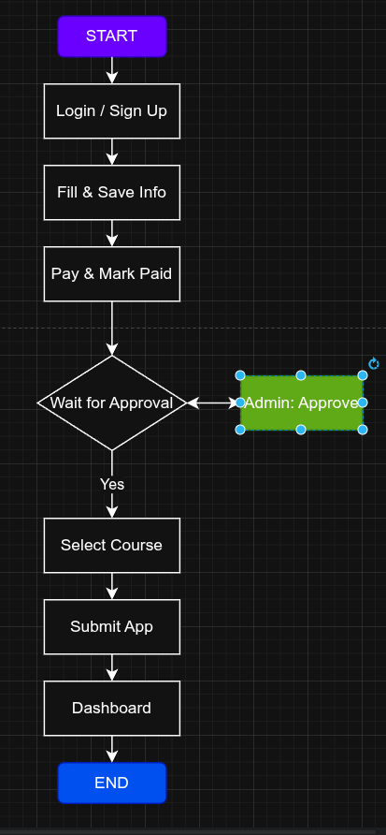

6.2. Admin Process
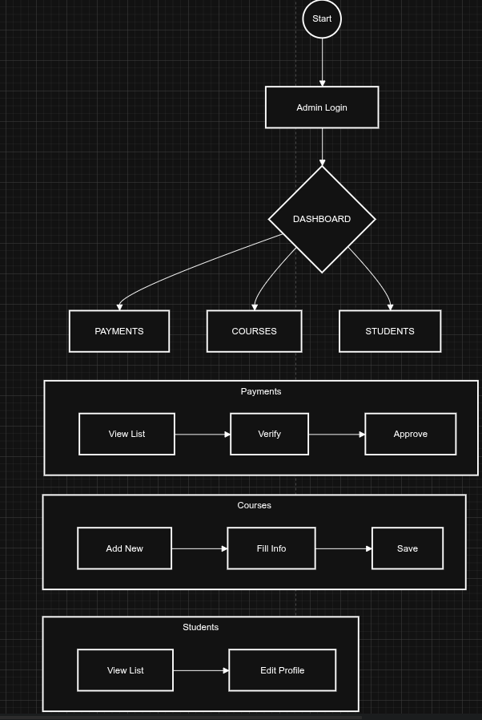

7. Security & Scalability

7.1. Security Measures
- Authentication: Django's built-in secure authentication system.
- Authorization: Role-based access control (RBAC). Only Staff can access the Admin panel; Students can only view their own data.
- CSRF Protection: Prevents Cross-Site Request Forgery attacks on forms.
- Data Validation: Server-side validation for all inputs (forms, file uploads).

7.2. Scalability Plan
- Database: Design supports migration to PostgreSQL for high-volume concurrent connections.
- Caching: Redis can be integrated for caching session data and speeding up WebSocket delivery.
- Media Storage: configured to serve static/media files efficiently (can be offloaded to AWS S3 or Cloudinary in the future).

8. UI/UX Design Strategy
- Theme: "Bright Future" theme using clean whites, professional blues, and success greens.
- Animations: Subtle fade-in effects to enhance user experience without causing distraction.
- Feedback: Immediate visual feedback (Toast messages) for actions like "Saved Successfully" or "Payment Pending".

9. Conclusion
The proposed design for the Bright Skills Development Center ensures a seamless, paperless experience for students while providing administrators with total control over the enrollment process. The modular architecture allows for easy future expansion, such as adding online payment gateways (Stripe/PayPal) or automated certification generation.

